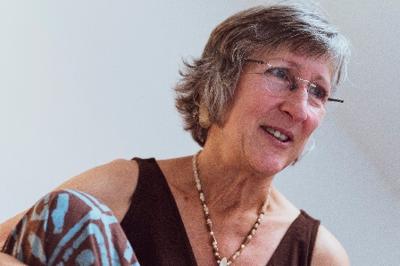
Charisse has 40 years’ experience working with people suffering from physical & psychological trauma. She worked with independent midwives in Alaska, assisted & taught with Ray Castellino, taught Pre & Perinatal therapy with Mary Jackson. She combines Craniosacral therapy & body centred psychotherapy with pre & perinatal awareness to help integrate somatically held traumatic memories.

She has a private practice in Scotland supporting individuals & families from varied backgrounds. She facilitates Birth Process Workshops, teaches Pre & Perinatal Therapy, mentors & supervises Castellino trained practitioners.

Charisse provides deeply intuitive presence & experience in the areas of contact, connection, creating boundaries & ways to develop meaningful connection with others without losing self.

ANNETTE PHOTO HERE

This workshop is co-facilitated with Annette Kux, a facilitator-in-training. She is a mother of 4 adult children all born at home. She has over XX years of experience as a physiotherapist being with babies & supporting end of life care in hospice.

‘Our deepest fear is not that we are inadequate. Our deepest fear is that we are powerful beyond measure. It is our light, not our darkness, that most frightens us. We ask ourselves, who am I to be brilliant, gorgeous, talented, and fabulous? Actually, who are you not to be?’
Marianne Williamson
(On the occasion of Nelson Mandela’s
inaugural speech)

An intimate group setting for a personal process - helping you to be who you truly are.
28 June - 2 July 2026
Anstruther, Scotland
Cost: £750 if paid before 17/5/26
£850 if paid after 17/5/26

Contact

Charisse Basquin
earlyimprintsuk@gmail.com

Integrating EARLY IMPRINTS
A Personal Process

Integrating Early Imprints

These workshops offer you a personal process to boost wellbeing, self-empowerment and freedom.

Through a safely guided exploration of early experiences, you’ll deepen your self-understanding and discover new ways of engaging with yourself and others.

The experiential nature of the workshop and the emphasis on safety and spaciousness allow you to go at your own pace, and experience profound transformation.

What are early imprints?

Early experiences shape the development of the brain and nervous system. From conception to the age of 3, many neural pathways are formed, laying down patterns in the relational areas of the brain. This is the foundation for bonding and attachment.

Memories and styles of relationship are woven into your body. They are like ‘imprints’ in your nervous system and continue to affect your behaviour, relationships, self-esteem and expectations, as well as your physical and emotional wellbeing.

The ideal is for a child to feel nurtured, loved, accepted and affirmed. Where there has been stress, upset or poor bonding, resulting imprints may make it difficult for a person, in adulthood, to manage stress or to fully enter into relationship.

Creating new imprints

The nervous system, including the brain, is malleable, and can develop new pathways throughout life in response to new experiences.

It is possible to create new imprints that are conducive to relational wellbeing, health, and personal growth. The process tends to be deeply healing and empowering.

What happens in workshop?

Using a sensitive process that taps into the body-held memories of your early life, it is possible to access and alter patterns that inhibit full self-expression or cause you difficulties today. You can create new imprints.

Each workshop has 4-6 participants.

Each participant receives an individual session that varies in length and approximates 2.5 hours. The group structure offers the opportunity for exploration beyond what may be possible within the context of one-to-one work.

The group setting can mirror original family dynamics, which aids the exploration of early influences, and because the group is supportive, both exploration and healing can take place in a safe and therapeutic way.

Requirements
To support this level of exploration, each participant is required to have engaged in some of their own therapeutic work and have access to follow-up therapeutic support after the workshop.
To support clarity and safety, each participant is also required to refrain from the use of recreational and spiritual medications/drugs at least 1 week and alcohol for 48 hours prior to and during the course of the workshop.
Participants agree to attend the entire workshop and agree to keep evenings free from commitments.

Some reflections
“For the first time I feel like I belong.”
“I’ve found my voice and am more able to say what I truly mean.”
“I rediscovered my laugh.”
“After 25 years of being a psychotherapist, I have found the missing piece.”

